**1.Identification of the substance/ mixture and of the company/ undertaking**

**1.1. Product identifier**

Trade name : M …( có PVA)

Chemical Name : Sizing agent.

**1.2. Recommended use of the chemical and restrictions on use**

Recommended use : Textile auxiliary

Non-recommended : none known.

**1.3. Details of the supplier of the safety data sheet**

Company : HUNG XUONG CHEMICAL CO., LTD.

Telephone : +84 272 377 8055/56

Telefax : +84 272 377 80

E-mail : info@hungxuong.com

**1.4. Emergency telephone number**

Emergency : +84 272 377 8055

Information :

**2. Hazards identification**

**2.1. Classification of the substance or mixture**

**GHS Classification and classification according to Regulation on classification and labeling of chemicals – Circular Number 32/2017/TT-BCT**

Acute toxicity-Inhalation: Category 4.

Serious eye damage/eye irritation: Category 2.

STOT-SE: Category 2.

**2.2. Label elements**

**GHS Label element**

Hazard pictograms :  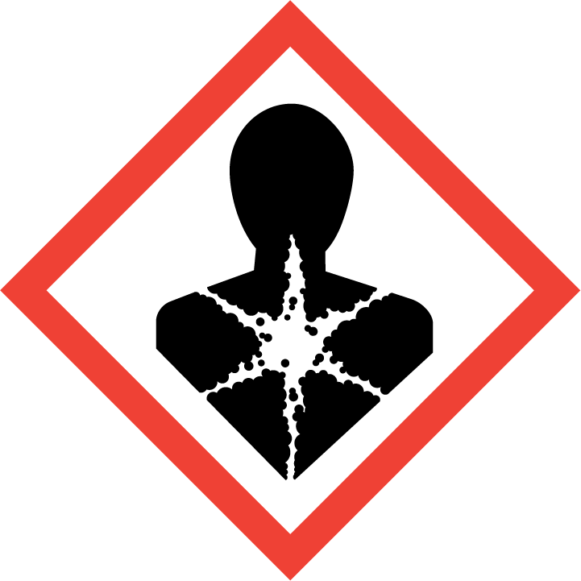

Signal word : WARNING

Hazard statement :

H332- Harmful if inhaled.

H319- Causes serious eye irritation.

H371- May cause damage to organs.

Precautionary statement:

Prevention:

P260- Do not breath dust/fume/gas/mist/vapours/spray.

P264- Wash hands thoroughly after handling.

P270- Do not eat, drink or smoke when using this product.

P271- Use only outdoors or in a well-ventilated area

P280- Wear eye protection/face protection.

Response:

P304 + P340- IF INHALED: Remove victim to fresh air and keep at rest in a position comfortable for breathing.

P317- Get medical help.

P305 + P351 + P338 – IF IN EYES: Rinse cautiously with water for several minutes. Remove contact lenses, if present and easy to do. Continue rinsing.

P337+ P317- If eye irritation persists: Get medical help.

P308 + P316- IF exposed or concerned: Get emergency medical help immediately.

Storage:

P405- Store locked up.

Disposal:

P501- Disposal of contents / container in accordance with national regulations

**2.3. Other hazards**

None known

**3. Composition/information on ingredients**

**3.1. Substance**

**3.2. Mixture**

Information on ingredients / Hazardous components

|  |  |  |  |
| --- | --- | --- | --- |
| Chemical Name | CAS-No | Concentration (%) | Classification GHS |
| Starch | 9005-25-8 | 93.5-95.0 | Acute Toxicity-Inhal.4, H332  Eye Irrit.2, H319.  STOT SE.3, H335. |
| Polyvinyl alcohol | 9002-89-5 |  | STOT SE.2, H371. |
| Paraffin and Hydrocarbon waxes | 8002-74-2 | 5.5-6.5 | No hazardous |

**4. First aid measures**

**4.1. Description of first aid measures**

General advice : If medical advice is needed, provide SDS document to physician.

Inhalation : Remove the victim from exposure or move to well- ventilated area.

If there is difficulty in breathing, medical advice is required.

Skin contact : After contact with skin, wash with plenty of soap and water.

Remove contaminated clothing, shoes and leather accessories.

Eye contact : Rinse cautiously with water for several minutes. Remove contact lenses, if present and easy to do. Continue rinsing. Immediately call a POISON CENTER or doctor/physician.

Ingestion : In case of swallowing, rinse mouth, drink plenty of water. If feel unwell, seek medical advice.

**4.2. Most important symptoms and effects, both acute and delayed**

Symptoms : no special hints

**4.3. Indication of any immediate medical attention and special treatment needed**

Treat symptomatically.

**5. Fire-fighting measures**

**5. Fire-fighting measures**

**5.1. Extinguishing media**

Suitable extinguishing media : fine water spray, foam, dry powder, CO 2

Unsuitable extinguishing media : no data available.

**5.2. Special hazards arising from the substance or mixture**

In the event of fire the following can be released: carbon monoxide, carbon dioxide.

**5.3. Advice for firefighters**

On burning, fire fighter should wear self-contained breathing apparatus if risk of exposure to product of combustion.

**6. Accidental release measures**

**6.1. Personal precautions, protective equipment and emergency procedures**

Use personal protective equipment

**6.2. Environmental precautions**

Prevent run off into drains and waterways.

**6.3. Methods and material for containment and cleaning up**

Sweep up spills then place into a suitable container for disposal.

**7. Handling and storage**

**7.1. Precautions for safe handling**

Advice on safe : wear protective equipment when working.

handling

Hygiene measures : Do not eat, drink or smoke when working. Wash hands before

breaks and after work.

General protective : Do not inhale dust. Avoid contact with eyes and skin.

measures

**7.2. Condition for safe storage, including any incompatibilities**

**Prevention of fire and explosion**

Information : no special measures required.

**Storage**

Information : none

Further Information on storage conditions:

Keep container or bag tightly closed and store in a cool, dry well- ventilated location.Store away from heat, flames, ignition sources and incompatibles. Check regularly for leaks.

**8. Exposure controls / Personal protection**

**8. Exposure controls / Personal protection**

**8.1. Control parameters**

Exposure limit(s) : No data available.

**8.2. Exposure controls**

Appropriate : operate in well- ventilated area.

engineering controls

Personal protective equipment

Eye protection : wear safety goggles.

Hand protection : protective gloves.

Body protection : protective working clothes and safety shoes.

Respiratory : wear respirator

protection

**9. Physical and chemical properties**

**9. Physical and chemical properties**

**9.1. Information on basic physical and chemical properties**

Physical state or appearance: Powder

Color : off- white.

Odor : characteristic

Odor Threshold : no data available.

pH of 1% water soluble (25°c) : 6.5-8.5

Melting point : no data available.

Boiling point : no data available.

Flash point : no data available.

Evaporation rate : no data available.

Flammability : no data available.

Upper Explosion/Ignition limit: no data available.

Lower explosion limit : no data available.

Vapour pressure : no data available.

Relative vapuor : no data available.

Relative density : no data available.

Solubility : soluble in water.

Partition coefficient : no data available.

(n-octanol/water)

Autoignition : no data available.

temperature

Thermal : no data available.

decomposition

Viscosity, kinematic : no data available.

Viscosity (viscosity cup nozzle diameter 6mm; t°= 90°c, RI =10): 15-16s

Oxidizing properties : no data available

**9.2. Other Information**

Density : no data available.

Metal corrosion : no data available.

**10. Stability and reactivity**

**10.1. Reactivity**

Stable in normal room temperature

**10.2. Chemical stability**

The product is stable under normal conditions.

**10.3. Possibility of hazardous reactions**

No dangerous reactions known

**10.4 Conditions to avoid**

Heat, flames, ignition sources and incompatibles, highly wet condition.

**10.5. Incompatible materials**

Avoid contact with strong acids and strong oxidizing agents.

**10.6 Hazardous decomposition products**

Carbon dioxide and carbon monoxide may form when heated to decomposition.

**11. Toxicological information**

**11.1. Information on toxicological effects**

Acute toxicity (oral) : not classified.

Acute toxicity : Harmful if inhaled.

(inhalation)

Acute toxicity (dermal) : not classified.

Irritation/corrosion : not classified.

of the skin

Serious eye damage/ : Causes serious eye irritation.

eye irritation

Repeated dose toxicity : not classified.

**CMR assessment**

Carcinogenicity : not classified.

Mutagenicity : not classified.

Teratogenicity : not classified.

Toxicity to reproduction: not classified.

Specific Target Organ : May cause damage to organs.

toxicity-single exposure.

Specific Target Organ : not classified.

toxicity-Repeated exposure.

Aspiration hazard : not classified.

**12. Ecological information**

**12. Ecological information**

**12.1. Ecotoxicity**

No data available.

**12.2. Persistence and degradability**

No data available.

**12.3. Bioaccumulative potential**

No data available.

**12.4. Mobility in soil**

No data available.

**12.5. Other adverse effects**

No data available.

**13. Disposal considerations**

**13.1 Waste treatment methods**

Waste from residue: Disposal should be in accordance with local regulations and legislation.

Contaminated packaging: Dispose of empty contaminated containers in accordance with regulations and legislation.

**14. Transport information**

Not classified as dangerous goods for transport

**D.O.T Road/Rail**

UN number : not applicable.

UN proper shipping name: not applicable.

Hazard label: not applicable.

Transport hazard class (es): not applicable.

Packing group : not applicable.

Transport in bulk : not applicable.

Special precaution for user: not applicable.

**Air transport ICAO-TI/IATA-DGR**

UN number : not applicable.

UN proper shipping name: not applicable.

Hazard label: not applicable.

Transport hazard class (es): not applicable.

Packing group : not applicable.

Transport in bulk : not applicable.

Special precaution for user: not applicable.

**Sea transport IMDG**

UN number : not applicable.

UN proper shipping name: not applicable.

Hazard label: not applicable.

Transport hazard class (es): not applicable.

Packing group : not applicable.

Environmental hazards (Marine pollutant): no

Transport in bulk : not applicable.

Special precaution for user: not applicable.

**15. Regulatory information**

**15.1 Safety, health and environmental regulations/ legislation specific for the substance or mixture.**

* Regulation on classification and labeling of chemicals - Circular Number 32/2017/TT-BCT. Date issued : 28/12/2017.
* Regulations on the list of hazardous industrial goods to be packed in the process of transporting and transporting dangerous industrial goods by road, rail and inland waterway transport - number: 44/2012/TT-BCT - Date issued 28/12/2012
* National technical standard for ambient air quality - QCVN05:2013/BTNMT
* National technical regulation on some hazardous substances in the surrounding air - QCVN06:2009/BTNMT
* Regulations on the labeling of chemicals based on GHS according to Circular No. 32/2017 /TT/ BCT
* Labor hygiene standards in the workplace-Decision, No.3733/2002/QD-BYT.
* National technical regulations - permitted exposure limit value for 50 chemicals at working-Circular number 10/2019-TT-BY

**16. Other information**

The information in the sheet were written based on the best knowledge and experience currently available but without liability.

SDS prepared on: 28/5/2020

Revision date : 28/6/2022

Version 2.0

Legend

TWA: Time Weighted Average

IATA: International Air Transport Association

ICAO: International Civil Aviation Organization

IMDG: International Maritime Dangerous Goods

Acute Toxicity-inhal.4: Acute toxicity inhalation, hazard category 4.

Skin Irrit.2: skin irritation, hazard category 2

Eye Irrt.2: eye irritation, hazard category 2

STOT SE 2: Specific target organ toxicity- single exposure, hazard category 2

STOT SE 3: Specific target organ toxicity- single exposure, hazard category 3

H332: Harmful if inhaled.

H315: Causes skin irritation.

H319: Causes serious eye irritation.

H335: May cause respiratory irritation.

H371: May cause damage to organs.

***THE END***